1. §This question relates to the design of an instrument for measuring bio-potentials.

1. Sketch a typical ECG waveform labelling each segment. Explain briefly what each segment of the ECG waveform represents during a single heartbeat.

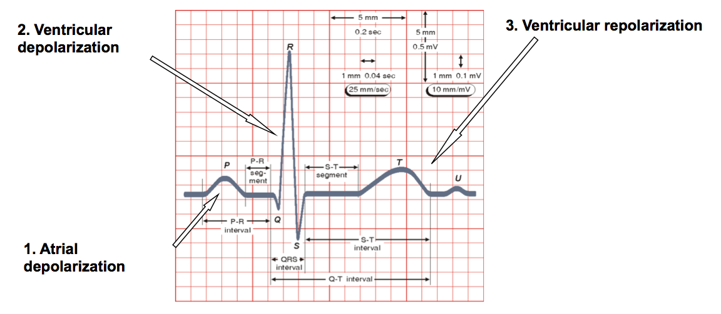

P wave represents the normal atrium (upper heart chambers) depolarization;

QRS complex (one single heart beat) corresponds to the depolarization of the right and left ventricles (lower heart chambers);

T wave represents the repolarization (or recovery) of the ventricles.

[2 marks for drawing with labels and 2 marks for brief explanations]

[4]

1. Table 1.1 lists five commonly observed bio-potentials and their amplitude and frequency characteristics. A doctor requires an instrumentation system to record the ECG from the heart. The front end will use the instrumentation amplifier shown in Figure 1

Design a complete instrumentation system for recoding ECG from the chest according to the following specifications:

Instrumentation Amplifier Gain: 50

VOUT = – (V1 – V2)(1 + 2R2/R1)(R4/R3)

For gain of 50 we select R4=R3=R2= 100 KΩ and R1= 4.02 KΩ

[1 mark]

Low-Pass Filter Roll off: 40dB/decade

2nd order sallen key filter.

Low pass value R3=1/2πC2fLPF = 1/2π(10n)(300Hz)=53KΩ [1 mark]

High-Pass Filter Roll off: 20dB/decade

First order RC

High pass value R2=1/2πC1fHPF = 1/2π(10nF)(0.1Hz)=160MΩ [1 mark]

Supply Range: -5V to 5V

VDD=5V, GND=0V, VSS=5V

Max ECG = 3mV (from table)

Vinptp x A1 x A2=10Vptp

A1=50

3mVx50xA2=10V

A2= 66.7 (gain of filter and final stage) [1 mark]

Realised with a non-inverting amplifier with R1=65.7KΩ and R2=1KΩ [1 mark]

Final Circuit:

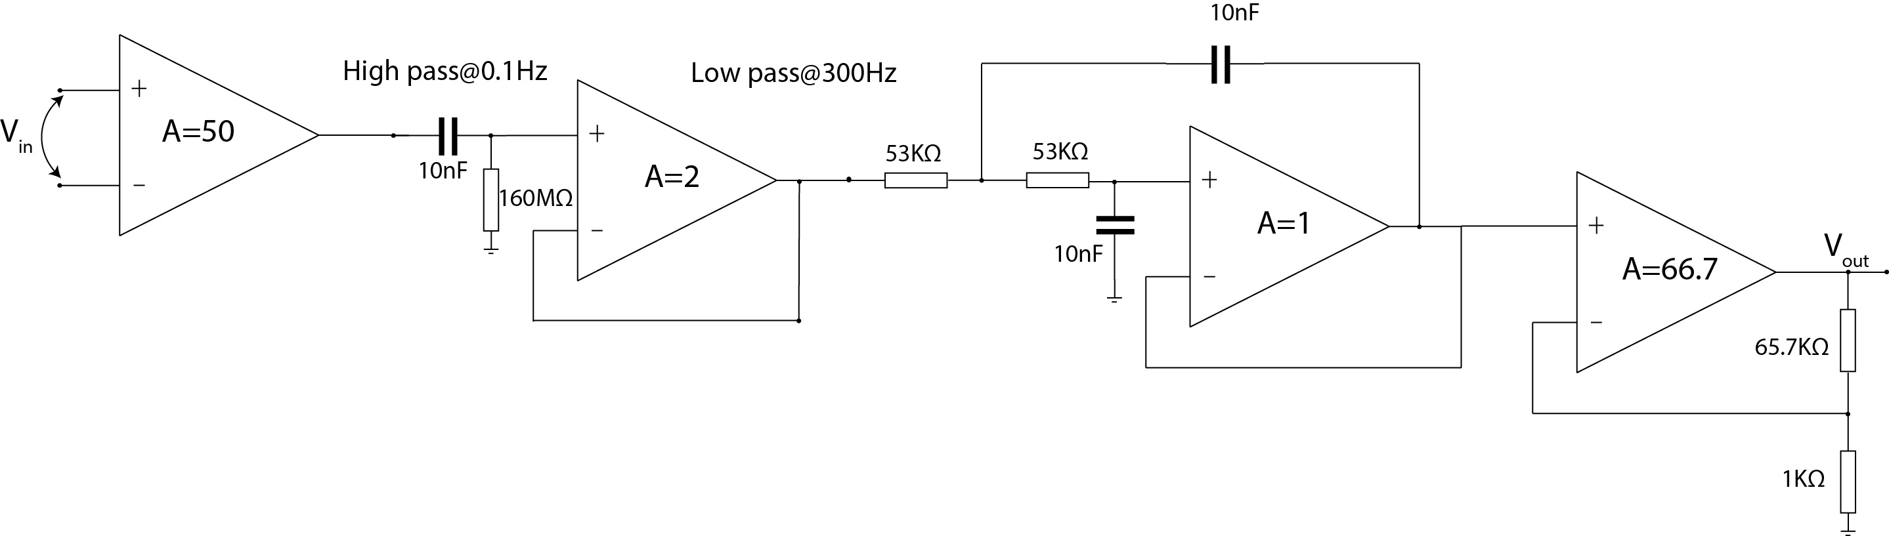

Complete circuit with annotated component values [4marks]

State all assumptions and values of resistors and capacitors used. You may assume that the instrumentation system utilizes the whole dynamic range available and 10nF capacitors are available for the filters.

[8]

1. i) Show how the circuit in Figure 1 can be modified with a “*driven right leg circuit”* to reduce the common mode voltage created by current capacitively coupled to the body from the power-lines.

Modification of instrumentation amplifier:



[2 marks for circuit]

ii) Show that the common mode voltage with this circuit reduces to:



Derivation from notes:



[2 marks]

1. After measurement of the ECG you notice that the instrumentation amplifier keeps saturating due to a large DC offset voltage between the input electrodes. The impedance of the input electrodes is 1MΩ. Sketch a modified instrumentation amplifier able to solve this problem,

Sketch of AC coupled Instrumentation Amplifier. Need to make sure HPF resistor values are 10x larger than impedance of electrodes. Previous calculation satisfies this criterion and thus the same RC values can be used. [Assumption 1 mark]

High pass value Rf=1/2πCffHPF = 1/2π(10nF)(0.1Hz)=160MΩ [1 mark]

Circuit [2 marks]

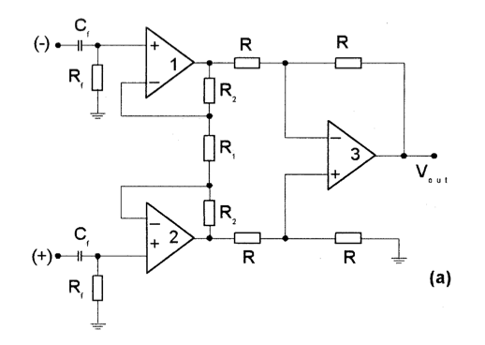 [4]

1. This question relates to the design of an instrument for detecting DNA.

1. Explain two methods which can be used to detect DNA, describing the physical phenomena which allows these detection methods.

Method 1: DNA has a negative backbone such that when it binds to it’ complementary pair, a change in charge occurs which can be detected by sensing the change in impedance.

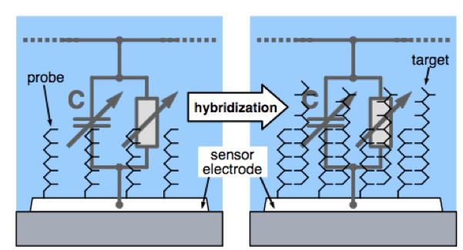[2 points]

Method 2: The incorporation of one nucleotide leads to the production of pyrophosphate and most importantly to the release of a hydrogen ion from the hydroxyl group of the 3’ terminal of the growing strand, leading to a change in the pH of the reaction due to the increase of the solution's acidity.

We can detect this change in pH using Ion-sensitive field effect transistors.

hydrolysis_2.pdf [2 points]

[4]

1. Next generation sequencing has been enabled due to the design of Ion Sensitive Field Effect Transistors (ISFETs) which allows detection of pH. Sketch a cross section of an ISFET and it’s macro-model, explaining its principle of operation and detailing equations of its drain current.

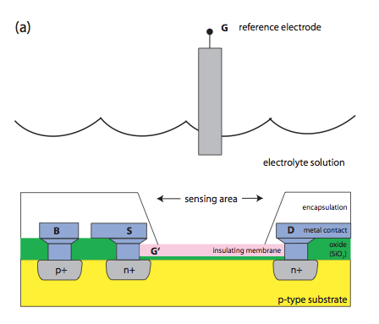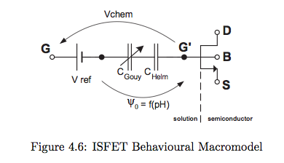

[4]

[4]

[2]

[Total 6 points]

1. Figure 2 show a typical reaction where there is a change in pH caused be DNA binding to its complementary pair. The output voltage shown is linearly dependent to the pH change.
   1. Sketch a suitable instrumentation system to interface to an ISFET for this reaction explaining its operation.

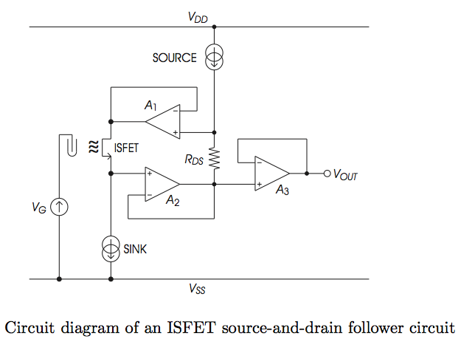[2]

Operation: Constant charge method (CCM).

Fix VG, ID, VDS to operate at a fixed working point.

VS then tracks changes in VT.

Opamp A2 tracks changes in VS and through feedback of A1, sets VD to ensure VDS is always constant. [2]

[4]

* 1. What is the total change in pH because of this reaction.

Total voltage change on graph is 25mV. We know Nernstian change is 59mV/pH. Hence total change in pH is 0.42.

[2]

1. A Reference-FET (REFET) is identical to an ISFET but insensitive to pH such that it can be used to create a differential circuit which can subtract any common mode noise in the reaction. Sketch a circuit comprising of an ISFET and REFET capable of outputting a voltage signal dependent only on the pH change of the reaction.

Differential Circuit will achieve this:

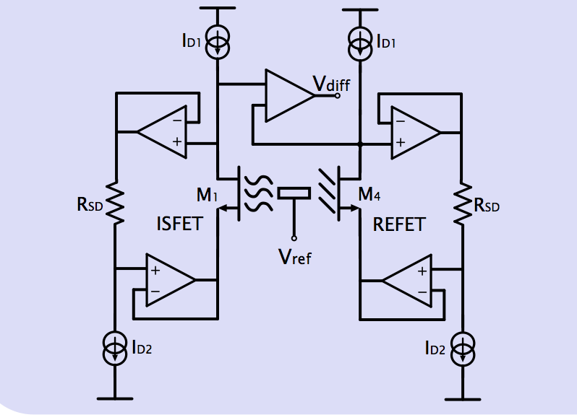

[4]

1. This question relates to the design of an electrical stimulation circuit for a cochlear implant.
2. Briefly discuss the relative advantages and disadvantages of using monopolar vs. a bipolar electrode configuration for this application with a 22-electrode linear array. [4]

* Monopolar: More channels for a given pitch between electrodes [1]

Lower power consumption [1]

* Bipolar: Better focality - reduced current spread [2]

1. The desired stimulation pattern is shown in Fig. 3. You are required to design a circuit to generate and deliver a stimulus considering the following specifications:

Stimulation type: Current-controlled

Electrode configuration scheme: bipolar

Electrode impedance: 10kΩ (assuming purely resistive)

Maximum current output (iMax): 1mA

Stimulus magnitude programmability: 2-bit

Sketch the design for a single channel (i.e. circuit schematic) providing a truth table, state transition diagram and/or combinational logic expressions for the controller. [10]

Stim_Figure3.pdf[5]

* Power supply = 10k x 1mA = 10V + 2V headroom ->+12V [1]
* A, B inputs to current magnitude control – provided as input to FSM. [1]
* C, D, E, F generated by FSM. [3 for truth table or combinational logic expressions]

1. If your stimulator design achieves a charge balance of ~1%, describe how any residual charge can be removed and how this can be incorporated within your design. [6]

* Using passive DC-blocking capacitors. However, these would need to be discrete – i.e. would need 22x ~100nF capacitors. Large capacitance needed to support Q=It required by maximum stimulus waveform (+ extra margin). [2]
* Using an active compensation scheme – e.g. observing electrode potential after anodic pulse and inserting appropriate current pulses until electrode potential is zero. [2]
* Applying an “electrode-shorting” phase where each electrode pair are shorted together (and to ground) every few stimulation cycles. This however would result in a dead-zone (no stimulation). [2]

Stim_Figure1.pdf

Figure 3

1. This question relates to an implantable Brain Machine Interface (BMI) for motor control.

The front-end architecture of a single channel is shown in Figure 4. This has been designed to interface with a multi-electrode array to observe **only** the *Extracellular Action Potentials (EAPs)* and **not** the *Local Field Potentials (LFPs)*. The front-end includes a front-end bio-potential amplifier (A1), a bandpass filter (to reject the LFPs), a second amplification stage (A2) and an Analogue to Digital Converter (ADC) to digitize the signal.

1. Given the signal characteristics and circuit constraints detailed in Figure 4, determine appropriate values for the gains (A1 and A2) and ADC Resolution (X) and Sampling rate (Y). State any assumptions made. [7]

If EAP range is 400uV max (ptp) to map onto 1.8V range (input of ADC) will need a total gain of 1.8V/400e-6=4,500=73.1dB. Therefore, can set A1=100, A2=45 (higher first stage gain to improve overall noise performance). [3]

If input noise=3uVrms -> output referred noise = 4uV x 4500 = 13.5mV. If we are to set LSB to be ½ the noise level -> LSB=13.5/2=6.75mV. Therefore, data converter resolution requires 1.8V/6.75mV levels (=266.6) => 9-bits. [3]

Given bandwidth of EAP=300Hz-3kHz, set sampling rate to 5x fmax =15kHz. [1]

1. If the system is to utilize a transcutaneous biotelemetry (for data output) with a 2Mbit/s data-rate, calculate how many channels can be supported (based on your answer to part (a)). [3]

Bits required per second/per channel = 9 x 15k = 135kbps => Given telemetry of 2Mbps -> maximum number of channels = 14.8 =~14.

1. Detail how the system could be modified to support a higher channel count (for the 2Mbit/s data rate) given that the features of interest are the EAP spike shapes and inter-spike intervals. Your answer should include a block-level diagram in describing the amended system. [7]

Can include a spike detection circuit based on a comparator and simple threshold to trigger whenever a spike is detected and then send out just the spike snippets. Assuming the length of each spike is 2ms and each channel records average of 10spikes/s/neuron and 2.5 neurons/channel. [4]

Maximum channels = 2Mbps / 15k x (2ms/1000ms) x 10 x 2.5 x 9 = ~296 channels. Therefore a 20x compression. [3]

1. State three reasons why it is *essential* for such a system to have low power consumption? [3]

* Energy capacity of batteries is limited.
* Energy consumed is ultimately dissipated as heat -> too much will cause tissue damage.
* Can maximize number of channels – given a certain energy budget/density of dissipation.

BMI.pdf

Figure 4

1. This question relates to the design of an artificial pancreas for treatment of diabetes.

1. Sketch a system level diagram of a closed loop system which works as an artificial pancreas and describe its operation highlighting three main disturbances to the system and two challenges.

Artificial Pancreas consists of continuous glucose sensor, insulin pump and controller.

Closed-loop diagram:

[5]

Explanation of operation (bookwork) highlighting Three disturbances: Meal, Exercise and Stress. [3]

One Challenge: CGM accuracy and delays due to the subcutaneous route of sensing and infusion. [2]

[10]

1. The blood glucose of a diabetic is expected to fluctuate in the range of 0-20mM. A continuous glucose sensor consists of an enzyme which can generate 10nA of current for every 1mM of glucose when biased with a redox potential of 700mV. Design a complete instrumentation system for an artificial pancreas to sense blood glucose using this enzyme which works off a 3V supply and maximizes the dynamic range available.

System:



[5 points]

Instrumentation to the sensor:

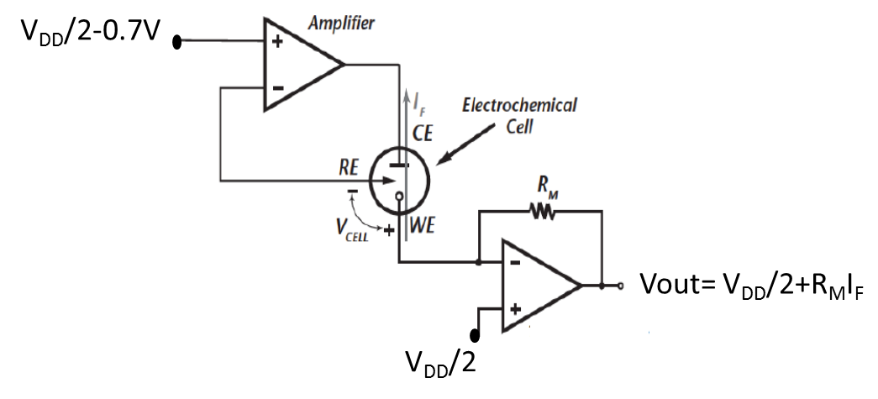[

Vcell= 0.7 V

VDD= 3V, IF,max= 200nA

RM\*IF,max=< 1.5V

Then RM =< 7.5 MOhm

[5 points]

[10]